import time

def intro():

print("Welcome to the Text Adventure Game!")

print("You find yourself in a dark room with two doors.")

print("Which door will you choose?")

time.sleep(1)

print("1. Left door")

time.sleep(1)

print("2. Right door")

choice = input("Enter 1 or 2: ")

if choice == "1":

left_door()

elif choice == "2":

right_door()

else:

print("Invalid choice. Try again.")

intro()

def left_door():

print("You open the left door and find a treasure chest.")

time.sleep(1)

print("Do you want to open the chest or go back?")

time.sleep(1)

print("1. Open the chest")

time.sleep(1)

print("2. Go back")

choice = input("Enter 1 or 2: ")

if choice == "1":

print("Congratulations! You've found the treasure and won the game!")

elif choice == "2":

intro()

else:

print("Invalid choice. Try again.")

left_door()

def right_door():

print("You open the right door and enter a room full of monsters!")

time.sleep(1)

print("You need to fight or run. What will you do?")

time.sleep(1)

print("1. Fight")

time.sleep(1)

print("2. Run")

choice = input("Enter 1 or 2: ")

if choice == "1":

print("You fought bravely but were overwhelmed by the monsters. Game Over!")

elif choice == "2":

print("You managed to escape and return to the starting room.")

intro()

else:

print("Invalid choice. Try again.")

right_door()

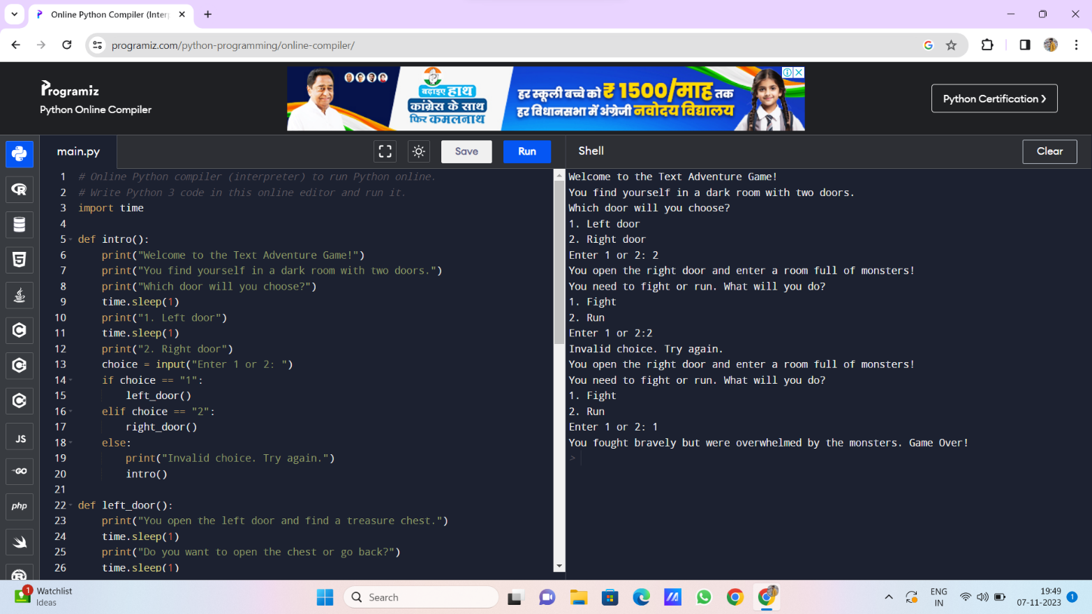# Start the game

intro()